|  |
| --- |
|  |
| Stride Phase 2 |
|  |
|  |
|  |
|  |

Table of Content

Overview 4

Scope 4

A. Changing Task Status To “Complete” 4

B. Rename “Closed” Status 4

C. Attachment Link Clickable 4

D. Tree View of Project, Modules and Tasks 4

E. Project And Module Filters In View Listings 5

F. Add “Duration” column in reports 5

|  |  |  |  |  |
| --- | --- | --- | --- | --- |
| **Prepared By** | **Reviewed By** | **Date** | **Approved By** | **Remarks** |
| Rathin Das |  |  |  |  |

|  |  |  |  |  |
| --- | --- | --- | --- | --- |
| **Version No** | **Remarks** | **Date Changed** | **Approved / Rejected By** | **Remarks** |
| 1 |  |  |  |  |

## Overview

The following enhancements will be taken up in phase 2 of Stride implementation

## Scope

### Changing Task Status To “Complete”

1. The status of the task cannot be changed to “Complete” until and unless all the members of that task have clicked on the “Stop” button.
2. The task should have been stopped by the members (provided they have clicked on “Start” initially) to allow the status change to “Complete”.
3. Appropriate error message will be displayed stating that there are active user for this task if a member tries to change the task status to “Complete”.

### Rename “Closed” Status

1. The task status “Closed” will be renamed to “Invalid”.
2. The task will be disabled when the status is changed to “Invalid”.
3. Like Point A above, if there are active users on that task, the task cannot be marked as Invalid. Appropriate message saying “This task cannot be marked as Invalid as there are active employees on this task.” will be displayed on the screen.

### Attachment Link Clickable

* + - 1. Make the attachment link clickable and downloadable on the comment history and trail history.

### Tree View of Project, Modules and Tasks

1. Users will have a tree view/hierarchy view of the project, modules, tasks and sub-tasks. A holistic view of the projects and modules will be available to the users.
2. The tree view/hierarchy view will look similar as shown below. All the members associated with a project will have access the view.

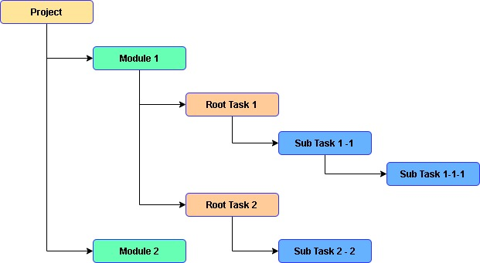

**Exhibit - 1: Task Tree View**

1. The view will be collapsible and expandable.
2. Against each task and sub-task, the task name will be displayed.
3. On clicking on any of the task the details page will open.
4. If the user clicks on a task in which he/she is not a member then that task will open in a read-only mode.
5. Tree view will have a search box to find the tasks. The Search box will be an open textbox where the user can add the Task Ref No. or Task Subject in full or part. That level will open in the tree view.
6. A button – ‘Sync with Task’ will be available above the tree view to open the tree view upto that task’s level.
7. On click of a task on the Tree View, the task will open on the left panel.

### Project And Module Filters In View Listings

1. The view listings namely “My Assigned Tasks”, “Created By Me”, “My Owned Tasks” will have filters based on Projects and Modules.
2. This will enable the users to narrow down the records in the view listing.

### Add “Duration” column in reports

1. In the reports apart from other columns there are two columns “Start Time”, “Stop Time”. A new column “Duration” will be provided which will be the difference between the Start and Stop time. The difference will appear in Days:Hours:Minutes:– eg. 2Days 2Hrs 30Mins (1 Day = 8 hours).
2. “Duration” column will give the exact time taken to complete a task.
3. Employee wise or Project Wise Total wherever possible should be shown.